General Approach to Planning Connectivity from Local Scales to Regional (GAP CLoSR)

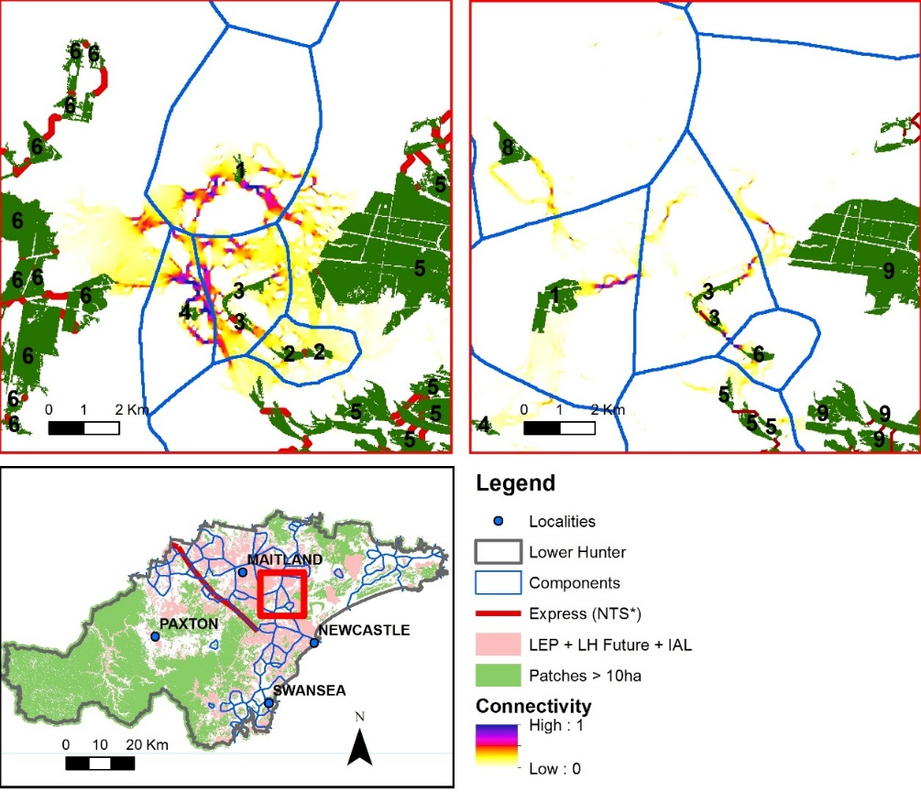

DRAFT MANUAL

Version 1.4

28/11/2014

Table of Contents

1 Introduction 4

2 About the tutorial 6

2.1 About 6

2.2 GAP CLoSR tool and example files 6

2.3 Terminology 8

3 Installing Software 9

3.1 ArcGIS 10.x 9

3.2 GAP CLoSR tools 9

3.3 Graphab 9

3.4 Circuitscape 10

4 Step1: Identify appropriate pixel sizes 11

5 Step 2: Data preparation for default scenario 12

5.1 Vegetation layer / raster template 12

5.2 Create Gap crossing layer 13

5.3 Create Landuse layer 15

6 Step 3: Data preparation for Scenario analysis 19

6.1 Prepare Raster Change layer 19

6.2 Modify vegetation layer - removal 21

6.2.1 Method: 21

6.3 Modify vegetation layer - Addition 22

Method: 22

6.4 Create new Gap Crossing Layer 24

6.5 Modify Landuse layer – New Infra 24

7 Step 4: Processing 25

7.1 Assigning dispersal cost to landcover types 25

7.2 Create Patch and resistance layer 26

8 Step 5: Running Model in Graphab 27

8.1 Step 1: Start new project 27

8.2 Step 2: Use Vegetation map to identify patches 28

8.3 Step 3: Use Landuse data 28

8.4 Step 4: Obtain result 29

8.5 Step 5: Create Graph 29

8.6 Step 6: Analyse data 30

8.7 Step 7: Export Data 31

9 Step 6: Running Circuitscape 32

9.1 Process data for Circuitscape 32

Method: 32

9.2 Processing data in Circuitscape 34

10 Troubleshooting 37

11 Appendix – Installing and running GAP CLoSR Tools GUI 38

11.1 Introduction 38

11.2 Installation 38

11.3 Required Files and Folders 38

11.4 Starting GAP CLoSR Tools 38

11.5 Configuring path to Python 38

11.6 How to use the example datasets 39

11.7 Normal Use of the Toolset 40

11.8 Running Tools 40

11.9 Running Multiple Tools 40

11.10 Script Errors 42

11.11 Computing Requirements 42

11.12 Configuration Notes 43

# Introduction

This manual is intended as a user guide for GIS practitioners to run the GAP CLoSR (General Approach to Planning Connectivity from Local Scales to Regional) connectivity modelling framework. It should be used in conjunction with the following report:

Lechner AM & Lefroy EC (2014) General Approach to Planning Connectivity from LOcal Scales to Regional (GAP CLoSR): combining multi-criteria analysis and connectivity science to enhance conservation outcomes at regional scale – Lower Hunter, University of Tasmania, Hobart, Tasmania. ISBN: 978-1-86295-731-2. <http://www.nerplandscapes.edu.au/system/files/LaP%20-%20GAP%20CLoSR%20Report%20%20-%20Lower%20Hunter_1.pdf>

The GAP CLoSR framework is a method for pre-processing your GIS data to match a conceptual model of fine scale dispersal behaviour describe by Doerr et al. 2012. The pre-processed data is then analysed in existing modelling software. Specifically Graphab and Circuitscape.

There are 4 key steps:

1. Data preparation
   1. Creation of data for baseline connectivity analysis (current connectivity)
   2. Creation of data for scenario analysis
2. Data processing
3. Run baseline or scenario with Graphab
4. Run baseline or scenario with Circuitscape

Z:\Dropbox_UTAS Papers\Lower Hunter paper 1 - connectivity model\FiguresTiff\Figure1small.tif

# About the tutorial

## About

The tutorial has been written so that users may replicate the methods used in the report for assessing connectivity between woody vegetation. Hence the terminology and the processing has been described in relation to modelling woody vegetation. However, as stated in the report there is the potential to run GAP CLoSR framework with a single species or dispersal guilds (e.g. ground-dwelling mammals). More information on modelling dispersal guilds can be found in the Midlands Report (<http://www.nerplandscapes.edu.au/GAP_CLoSR>).

The framework represents a loose set of tools and ideas and does not need to be used prescriptively. Depending on the target group/species and spatial data the method should be modified accordingly. As you could imagine there is an infinite combination of circumstances in which connectivity modelling will be conducted thus it is impossible to provide advice for every situation in which connectivity modelling may be used. The GAP CLoSR framework and tools represent a starting point for modelling fine-scale dispersal patterns.

The tutorial describes the processing steps (e.g. the buttons to click) and does not provide ecological or modelling advice, which is found in the report. It is important to consult the literature and experts to ensure that what is being produced is ecologically valid.

This tutorial is provided free of charge and it is hoped the reader will provide constructive feedback where appropriate as this document will forever be a work in progress.

## GAP CLoSR tool and example files

The manual should be used with example data and the GAP CLoSR tools for running the connectivity model. The latest version of the tool can be downloaded from <https://github.com/GAP-CLoSR/GAP-CLoSR-Tools-DOWNLOAD>

Below are descriptions of the folders that are found as part of the GAP CLoSR tools:

|  |  |
| --- | --- |
|  |  |
| GAP_CLoSR_Code | Python files for processing data |
| Scenarios | [Locat](https://github.com/GAP-CLoSR/GAP-CLoSR-Tools-DOWNLOAD/commit/dd154bf3e6745f06e9aa9c380e9dee27abd1947e)ion of scenario configuration file |
| TestData | [Example](https://github.com/GAP-CLoSR/GAP-CLoSR-Tools-DOWNLOAD/commit/dd154bf3e6745f06e9aa9c380e9dee27abd1947e) data |
| AltScriptPath.txt | Text file with filepath describing location of GAP CLoSR files |
| GAP CLoSR Toolbox.tbx | ArcGIS Model |
| GAP_CLOSR_Tools Installation Notes.pdf | [Text](https://github.com/GAP-CLoSR/GAP-CLoSR-Tools-DOWNLOAD/commit/dd154bf3e6745f06e9aa9c380e9dee27abd1947e) file describing how to install the tools |
| GAP_CLoSR_Tools.exe | Executable file for running Graphical User interface (this is the file you click on!!) |

There are four options for running the GAP CLoSR framework

1. Run the GAP CLoSR tool GUI (Graphical User Interface) [GAP_CLoSR_Tools.exe](https://github.com/GAP-CLoSR/GAP-CLoSR-Tools-DOWNLOAD/blob/master/GAP_CLoSR_Tools_v1.01/GAP_CLoSR_Tools.exe)
2. Run the ArcGIS Model builder tools (*note these are a bit buggy* at the moment) 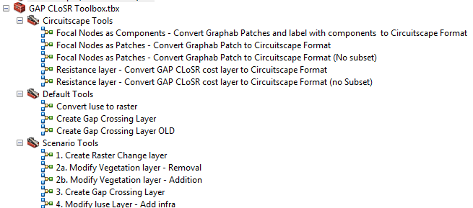
3. Run GAP CLoSR from Python IDE or command line [GAP_CLoSR_Code](https://github.com/GAP-CLoSR/GAP-CLoSR-Tools-DOWNLOAD/tree/master/GAP_CLoSR_Tools_v1.01/GAP_CLoSR_Code)
4. Process by hand using GIS software

In the tutorial we will describe how to use the GAP CLoSR tool primarily through the GAP CLoSR Tools GUI interface. We also provide graphical descriptions of the processing based on the ArcGIS Model builder tools.

The GAP CLoSR tools’ files do not need to be installed, they just have to be downloaded onto your PC.

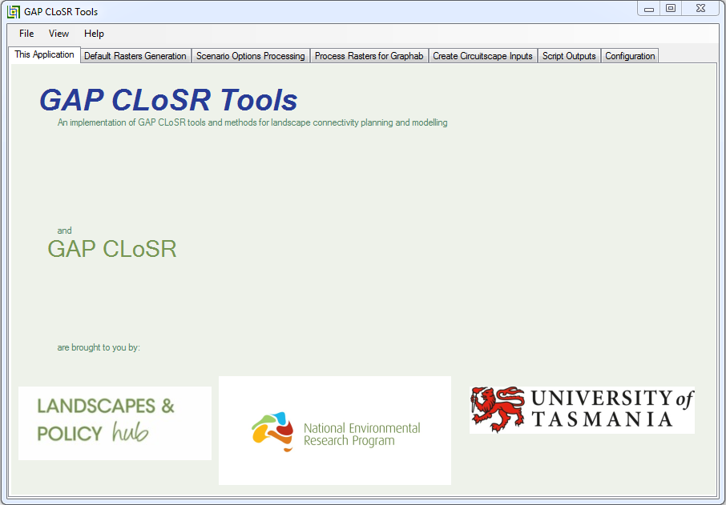

***GAP CLoSR Tools Graphical User Interface (GUI)***

If running the GAP CLoSR Tools GUI, open the Configuration Tab and ensure that the file path to Python (python.exe) is correct. A simple way of doing this is searching for “python.exe” in windows explorer. Then copy that file path + python.exe and paste it into the GUI. Once the python has been located click on save config. More information on running GAP CLoSR Tools GUI can be found in the Appendix.

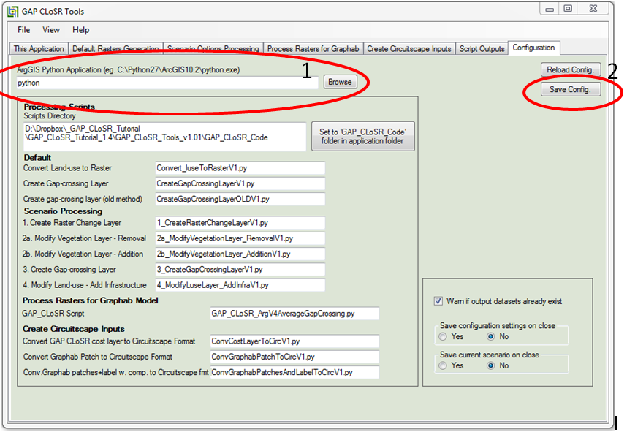

## Terminology

[By Hand] – indicates there is no automation of this step as there is often an infinite number of ways in which the processing could be done.

Text in red – describes datasets

Text in green – describes values or variable names

# Installing Software

Before getting started you will need to install the following software:

1. ArcGIS 10.x
2. GAP CLoSR tool
3. Graphab
4. Circuitscape

## ArcGIS 10.x

GAP CLoSR tools has been tested on ArcGIS 10.1. However, earlier or later versions of ArcGIS may also work. ArcGIS’s uses the programming language Python to run many of its tools. GAP CLoSR automates some of the pre-processing of the input raster data sets using the Python libraries associated with ArcGIS.

## GAP CLoSR tools

The latest version of the tool can be downloaded from <https://github.com/GAP-CLoSR/GAP-CLoSR-Tools-DOWNLOAD>. Click on “Download ZIP” in the bottom right hand corner of the screen click on “Download ZIP” in the bottom right hand corner of the screen.

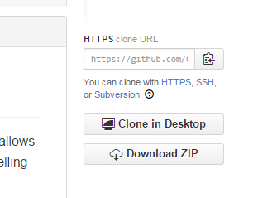

**Github download site**

These files include the python code, the model builder tools and the GUI.

## Graphab

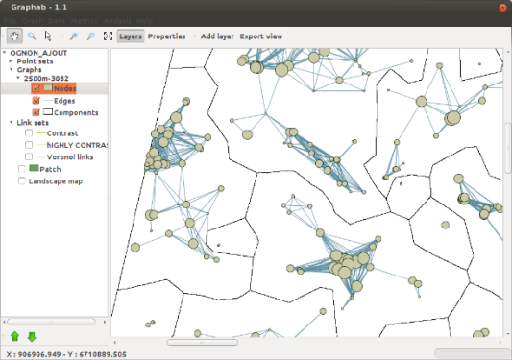

Graphab may be downloaded from:

<http://thema.univ-fcomte.fr/productions/graphab/>

The version tested was Graphab 1.2.1.

Software, documentation (including a manual), installation instructions and a user forum can be found on their website.

## Circuitscape

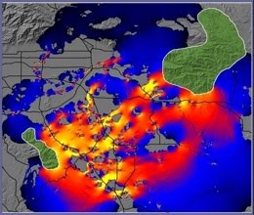

Circuitscape may be downloaded from:

<http://www.circuitscape.org/>

Software, documentation (including a manual) and installation instructions is available from the website.

Circuitscape-3.5.8-x64 was used.

<https://code.google.com/p/circuitscape/downloads/list>

Questions may be posted on the user forum:

<https://groups.google.com/forum/?hl=en#!forum/circuitscape>

# Step1: Identify appropriate pixel sizes

**Aim:** Identify the pixel size for processing raster input layers in GAP CLoSR [pre-processing pixel size] and also the pixel size for processing in Graphab and Circuitscape softwares [Output pixel size].

GAP CLoSR uses three datasets as inputs into GAP CLoSR processing:

1. Vegetation / habitat layer
2. Gap crossing layer
3. Dispersal cost surface

These datasets need to share a common pixel size [pre-processing pixel size]. The pixel size should be as fine as possible so as not to lose any information – but not below the resolution at which the data was produced.

These datasets are processed by GAP CLoSR to create two new datasets for the connectivity modelling software at a coarser resolution [Output pixel size]:

1. Vegetation layer/ habitat (raster file)
2. Resistance layer (shape file)

It is important to choose an Output pixel size that is not too fine as both Graphab and Circuitscape will crash if the landscapes are too complex – a property of pixel size, number of patches, the size of those patches and the resistance surface. The choice of pixel size also needs to be balanced with species ecology. For example if the maximum Interpatch dispersal distance of a species is 250m a pixel size of 500m would not be sensible. Finally it is important to choose a pixel size that is a multiple of all the input layers into the connectivity modelling software to reduce the impact of resampling error. For example resampling from 5m to 17m will require interpolation at the boundaries of the pixels. While resampling from 5m to 20m has requires no interpolation and the value of a 20m pixel can be based on the average of the pixel values.

A good way of testing what the finest pixel size at which the connectivity models will run on is to test only the vegetation layer and then add a resistance surface.

Identifying the pixel size that will be used for processing is a very important first step when conducted your own modelling in your study areas. The processing notes in the following chapters will provide you with the skills to test the pixel size. However, this needs to be the first step in any modelling exercise.

|  |
| --- |
| **EXAMPLE - testing pixel sizes**   1. Use binary vegetation layer 2. Run Graphab with only the patches – no dispersal cost surface. 3. Test multiple pixel sizes 4. Add simple resistance surface - generally the addition of a resistance surface in Graphab will increase the complexity of the processing. |

Note: It is important when changing resolution not to smooth (e.g. average filter) the image if it has a categorical classification such as in the case of the vegetation layer. Doing this will result in artefacts of the geoprocessing. If changing from a coarser to fine resolution (e.g. from 12.5m to 2.5m) use “nearest neighbour resampling” or a majority rule or median (Aggregate (Spatial Analyst) ([*http://resources.arcgis.com/en/help/main/10.1/index.html#//009z00000034000000*](http://resources.arcgis.com/en/help/main/10.1/index.html#//009z00000034000000) ).

# Step 2: Data preparation for default scenario

The default scenarios represents current connectivity in the study area. The following steps represent the processing that needs to be conducted before the data is processed for Graphab and Circuitscape software (section 8).

## Vegetation layer / raster template

**Aim:** Identify a binary vegetation layer that will be used to characterise habitat patches.

**Input layers:** Vegetation layer that identifies habitat patches.

Method:

Convert the vegetation layer into a raster grid (if it isn’t already). Ensure that it is at the pre-processing pixel size [BY HAND]. This vegetation layer will be used as a template. Areas outside the study need to be NoDATA. This will often be a two step procedure in ArcGIS:

1. Clip raster (<http://resources.arcgis.com/en/help/main/10.1/index.html#//00170000009n000000>)

2. Extract by mask (<http://resources.arcgis.com/en/help/main/10.1/index.html#//009z0000002n000000>)

Note: If converting coarser resolution imagery to finer resolution imagery use nearest neighbour resampling so that there will be no smoothing and the characteristics of the original image will be retained.

 **Raster template** - All rasters need to have exactly the same extent, grid size and position.

It is important to ensure that a single raster layer is used as a template for all rasters created in the following processes (Raster template). Whenever rasters are generated use the SNAP RASTER in the ENVIRONMENT SETTINGS and specify EXTENT, and CELL SIZE to ensure that the grid position, pixel size, number of columns and rows is exactly the same as the template raster if processing by hand.

Note: Sometimes rasters appear similar when overlaid in ArcGIS, however, there are areas of noData which will result in differing extents. Start by clipping the raster, then use raster mask if you want to include noData areas i.e. if the study area is not a rectangle such as in the case of a catchment boundary.

|  |
| --- |
| **TUTORIAL – Identifying characteristics of rasters**  Right-click on “TestData\DefaultAndScenario\veg” raster layer in the ArcGIS contents page to look at the characteristics of the raster layers. It is important that all layers have the same number of **Columns** and **Rows**, **extent** and **pixel size**. |

## Create Gap crossing layer

**Aim:** Create a binary Gap Crossing Layer to dscribe where structural connectivity exists at the gap crossing threshold.

**Input layers:** Vegetation layer

**Output layer:** Gap Crossing Layer

**Method:**

1. Process vegetation layer to create gap-crossing layer (see fig. below) by buffering high spatial resolution vegetation data representing structural connectivity elements by half of the gap-crossing threshold distance – e.g. 106 m gap crossing distance = 53 m. Areas outside of the buffer area are represented as dispersal barriers for least cost path mapping.

D:\Dropbox_UTAS Papers\Lower Hunter paper 1 - connectivity model\FiguresTiff\Figure2v2.tif

**a & b) Vegetation buffered by 53 m to simulate a 106 m gap crossing threshold. c) Gap-crossing layer where white indicate areas where dispersal can’t take place.**

|  |
| --- |
| **TUTORIAL – Create Gap crossing layer**  Location of the veg data “TestData\Inputs_DefaultAndScenario\veg”  Follow these steps to process the tutorial data.    Notes on Step 1: Specify the raster input and output folder. The outputs of GAP CLoSR will be stored in the same folder as the inputs  Notes on Step 2: Specify the name of vegetation raster (specify folder name).  Notes on Step 3: The new “Gap-Crossing raster” will be saved in the “input and output folder “. The Maximum distance = Gap Crossing Distance / 2 as integer (whole number).  Notes on Step 4: Click Run to create Gap-crossing raster.  File:Exclamation mark red.png Raster data in ESRIS ArcGIS Grids are stored as folders. To select an ArcGIS grids in the GUI specify the folder not the filename.  File:Exclamation mark red.pngNote Step 4: Once the run button has been clicked the GUI will become unresponsive until the script is done. Check the “Script Outputs” to see if it was successful. |

|  |
| --- |
| **ArcGIS Model – “GAP CLoSR Toolbox.tbx\Default Tools\Create Gap Crossing Layer”**     1. Reclassify the vegetation layer into veg and no data. 2. Create Euclidian distance layer 3. Convert Euclidian distance layer to 1 and 0. Where 1 represents areas within the gap crossing threshold and 0 indicate areas where the distance is greater than the gap crossing threshold. |

## Create Landuse layer

**Aim:** Create a raster landuse layer from shapefile (vector landuse) layer input with the same characteristics (extents, cell size etc) as the template.

**Input layers:** Shapefile vector landuse layer and raster template.

**Output layer:** raster landuse layer

**Method:**

1. [BY HAND] Convert landuse layer to logical categories related to dispersal e.g. hydrology, infrastructure, transport. Leave areas with no dispersal cost as unclassified. These areas should mainly be farmland.

|  |
| --- |
| **EXAMPLE Landuse layer**  Only polygons that will reduce dispersal need to be identified and categorised. This landuse layer will be converted into the resistance surface. |

|  |  |  |  |
| --- | --- | --- | --- |
| **EXAMPLE - Converting landuse layer to logical categories**  The following steps were used in the Lower Hunter to create a classified landuse layer that can be later be converted into a dispersal cost surface. The process begins with a standard Landuse later.  **STEP 1 - 1st Level**  Create new landuse layer which include the following categories that will reduce dispersal  'Intensive Animal Production', 'Mining & Quarrying' , 'Power Generation', 'River & Drainage System' , 'Special Category', 'Transport & Other Corridors' and 'Urban'   |  | | --- | | Processing  Select by the following SQL and then export to new shapefile:  "LU_NSWMajo" = 'Intensive Animal Production' OR "LU_NSWMajo" = 'Mining & Quarrying' OR "LU_NSWMajo" = 'Power Generation' OR "LU_NSWMajo" = 'River & Drainage System' OR "LU_NSWMajo" = 'Special Category' OR "LU_NSWMajo" = 'Transport & Other Corridors' OR "LU_NSWMajo" = 'Urban' |   **STEP 2 - 2nd Level**   |  | | --- | | Processing  Add new attribute (Column) and reclassify landcover classes  Reclassify landcover classes into the four categories  Infra value  "LU_NSWDeta" = 'Aerodrome/airport' OR "LU_NSWDeta" = 'Aquaculture - fish, prawn, yabby or beach worm farm' OR "LU_NSWDeta" = 'Caravan park or mobile home village' OR "LU_NSWDeta" = 'Conveyor Belt' OR "LU_NSWDeta" = 'Disused power station' OR "LU_NSWDeta" = 'Electricity generation (power station and associated stockpiles, hydro-electric plants' OR "LU_NSWDeta" = 'Electricity substation' OR "LU_NSWDeta" = 'Farm Infrastructure - house, machinery & storage sheds and garden areas' OR "LU_NSWDeta" = 'Fly ash dam/spoil dump' OR "LU_NSWDeta" = 'Industrial/commercial' OR "LU_NSWDeta" = 'Intensive animal production' OR "LU_NSWDeta" = 'Intensive animal production - dairy shed' OR "LU_NSWDeta" = 'Intensive animal production - deer' OR "LU_NSWDeta" = 'Intensive animal production - horse' OR "LU_NSWDeta" = 'Intensive animal production - ostriches' OR "LU_NSWDeta" = 'Intensive animal production - poultry' OR "LU_NSWDeta" = 'Landfill (garbage)' OR "LU_NSWDeta" = 'Marina' OR "LU_NSWDeta" = 'Mine site' OR "LU_NSWDeta" = 'Quarry' OR "LU_NSWDeta" = 'Residential' OR "LU_NSWDeta" = 'Rural residential' OR "LU_NSWDeta" = 'Sewage disposal ponds' OR "LU_NSWDeta" = 'Surf club and/or coastal car parking facilities' OR "LU_NSWDeta" = 'Tourist development' OR "LU_NSWDeta" = 'University or other tertiary institution' OR "LU_NSWDeta" = 'Urban recreation' OR "LU_NSWDeta" = 'Water supply pressure reservoir including water filtration plant'  Trans  "LU_NSWDeta" = 'Railway' OR "LU_NSWDeta" = 'Road or road reserve'  Hydro  "LU_NSWDeta" = 'Canal (canal estate, navigation canal)' OR "LU_NSWDeta" = 'Coastal lake' OR "LU_NSWDeta" = 'Drainage channel (from irrigation system or a channel draining a swamp; base of channel is lined)' OR "LU_NSWDeta" = 'Estuarine waters' OR "LU_NSWDeta" = 'Farm dam' OR "LU_NSWDeta" = 'Lagoon or inland lake' OR "LU_NSWDeta" = 'Reservoir' OR "LU_NSWDeta" = 'River training work' OR "LU_NSWDeta" = 'River, creek or other incised drainage feature; includes cowals in western NSW' 10 OR "LU_NSWDeta" = 'River, creek or other incised drainage feature; includes cowals in western NSW - with a woody vegetation cover of open forest' OR "LU_NSWDeta" = 'River, creek or other incised drainage feature; includes cowals in western NSW - with a woody vegetation cover of woodland' |   **STEP 3 – Accuracy assessment**  Check accuracy of classes within each category using aerial photography. And reclassify by hand where incorrect. This may include changing the whole class from one group to another or changing specific polygons.   |  | | --- | | Processing  Example of Lower Hunter Processing.  Red = infrastructure; blue = hydrology; Purple = transport; green = no resistance; Gray = classified by hand;  FID,LU_NSWDeta,Cnt_LU_NSWDeta  -1,Aerodrome/airport,6  -1,"Airstrip (local/farmer, grass or bare surface, not sealed)",1  -1,"Aquaculture - fish, prawn, yabby or beach worm farm",4  -1,Beach,32  -1,"Canal (canal estate, navigation canal)",3  -1,Caravan park or mobile home village,49  -1,Cemetery,28  -1,Marina,7  -1,Mine site,44  -1,No identified use,20  -1,Quarry,63  -1,Railway,10  -1,Reservoir,2  -1,Residential,253  -1,Residential - with a woody vegetation cover of open forest,6  -1,Residential - with a woody vegetation cover of woodland,3  -1,Restored mining lands,23  -1,Restored sand mining area,26  -1,River training work,6  -1,"River, creek or other incised drainage feature; includes cowals in western NSW",30  -1,"River, creek or other incised drainage feature; includes cowals in western NSW - with a woody vegetation cover of open forest",30  -1,"River, creek or other incised drainage feature; includes cowals in western NSW - with a woody vegetation cover of woodland",13  -1,Road or road reserve,126  -1,Rural recreation. Blocks are isolated and not associated with an urban area,1 | |

1. Convert file to a raster classified landuse shapefile to raster with same extents and pixel size as the template raster.

|  |
| --- |
| **TUTORIAL – Create landuse raster**  Location of the landuse data: “TestData\Inputs_DefaultAndScenario\luse.shp”    Notes on Step 4: Landuse- ID field refers to a integer attribute that uniquely identifies landcover based on how it affects dispersal. This will be reclassified in the next step based on resistance values. |

|  |
| --- |
| **ArcGIS Model - “GAP CLoSR Toolbox.tbx\Default Tools\Convert luse to raster”** |

# Step 3: Data preparation for Scenario analysis

In the previous section we described how to process data for the current/existing connectivity. This section describes how to alter the current/existing connectivity based on landuse scenarios such as a new housing development or a restoring a habitat patch. In all cases the spatial area of a landuse and vegetation change is specified with a shape file.

## Prepare Raster Change layer

**Aim:** Create a binary (e.g. 0 and 1) Raster Change layer where areas of vegetation removal (impact) or addition (revegetation) occurs with value 1.

**Input layers:** Polygon Change layer (e.g. development layer) that describes the extent of clearing or a layer that describes the location of revegetation and Raster template from previous step.

**Output layer:** Raster Change layer

**Method:**

1. In ArcGIS create new shapefile representing the Change extent layer [BY HAND]. Use the create feature class tool <http://resources.arcgis.com/en/help/main/10.1/index.html#//005600000004000000>
2. Add new column in called clear with the value 1. [BY HAND]

|  |  |
| --- | --- |
| **EXAMPLE – Characteristics of shapefile specifying the spatial extent of change** | |
| All polygons should have a value of 1 | Ensure the Polygon Change layer background has no values |

1. Create new column in Polygon Change layer called clear with the value 1. [BY HAND]
2. Convert shapefile into raster with same characteristics as template raster.

|  |
| --- |
| **Tutorial – Convert change layer into raster**  Location of Polygon Change layer data: “TestData\Inputs_DefaultAndScenario\ChangeLayer.shp” |

|  |
| --- |
| **ArcGIS Model – “GAP CLoSR Toolbox.tbx\Scenario Tools\1. Create Raster Change layer”**     1. Using the Raster template create a polygon layer that describes the extent of the input rasters with a value of 0. 2. The Polygon change layer is first dissolved to create a single feature within a polygon file. Then the Polygon change layer union’ed with output from a previous step to create a polygon with value of 0 for background and value of 1 for change areas (e.g. development boundaries). 3. Convert polygon to raster based on the field “clear” to create Raster Change layer. Ensure that extents are the same Raster template. |

## Modify vegetation layer - removal

**Aim:** Modify Vegetation layer by removing vegetation to simulate a landuse scenario.

**Input layers:** Vegetation layer and Raster Change layer

**Output layer:** Modified Vegetation layer

### Method:

1. Use Raster Change layer to remove vegetation from the original vegetation layer.

|  |
| --- |
| **Tutorial – Remove vegetation based on landuse scenario**  Location of the Raster Change layer: “D:\TestData\Inputs_DefaultAndScenario\changeLayer”  Location of the Vegetation layer: “D:\TestData\Inputs_DefaultAndScenario\veg” |

|  |
| --- |
| **ArcGIS Model – “GAP CLoSR Toolbox.tbx\Scenario Tools\2a. Modify Vegetation layer - Removal”**    In raster calculator use the following:  Con("%Input: ChangeLayer%"==1,0,"%Input: Vegetation Layer%")  Where, all pixel values in the Raster Change layer that equal 1 and result in a value of 0 in the Vegetation layer. |

## Modify vegetation layer - Addition

**Aim:** Modify Vegetation layer by adding vegetation to simulate scenario. Vegetation is restricted to areas that would naturally have vegetation and do not include areas where water bodies exist.

**Input layers:** Vegetation layer, land use layer and Raster Change layer

**Output layer:** New Vegetation layer

### Method:

1. Use Raster Change layer to add vegetation to the original vegetation layer.
2. Specify areas where hydrological features occur (or landuse values in which vegetation should not be added).

|  |
| --- |
| **Tutorial – Add new vegetation**  Location of the Raster Change layer: “D:\TestData\Inputs_DefaultAndScenario\changeLayer”  Location of the Vegetation layer: “D:\TestData\Inputs_DefaultAndScenario\veg”  Location of the landuse data: “TestData\Inputs_DefaultAndScenario\luse”    *Note Step 6: Hydrology raster value refers to landuse code (integer) which identifies hydrological features or features which represent areas where vegetation should not be added.* |

|  |
| --- |
| **ArcGIS Model – “GAP CLoSR Toolbox.tbx\Scenario Tools\ 2b. Modify Vegetation layer - Addition”**    In raster calculator use the following:  Con(("%Input: ChangeLayer%"==1) & ("%Input: luse%" != %Input: Hydrology layer value%),1,"%Input: Vegetation Layer%")  Where - All pixel values in the Raster Change layer that equal 1 and don’t equal “Input: Hydrology layer” (the pixel value of hydrology in the landuse layer) result in a value of 1 in the Vegetation layer. |

## Create new Gap Crossing Layer

**Aim:** Create a binary Gap Crossing Layer that describes where structural connectivity exists at the gap crossing threshold.

**Input layers:** Modified Vegetation layer

**Output layer:** Gap Crossing Layer

|  |
| --- |
| *TO DO* |

|  |
| --- |
| Same as ” 6.2 Create Gap crossing layer” |

## Modify Landuse layer – New Infra

**Aim:** Modify Landuse layer adding infrastructure/development/housing to simulate a development scenario where there is new infrastructure (e.g. such as housing). In the case of adding vegetation this is restricted areas that would naturally have vegetation and not include areas where water bodies exist.

**Input layers:** Landuse layer and Raster Change layer

**Output layer:** New Landuse layer.

|  |
| --- |
| **Tutorial – Modify landuse raster by adding infrastructure in all areas apart from hydrology**  Location of Raster Change layer: “D:\TestData\Inputs_DefaultAndScenario\changeLayer”  Location of landuse layer: “TestData\Inputs_DefaultAndScenario\luse”    Note Step 6: Hydrology raster value refers to landuse code (integer) which identifies hydrological features or features which represent areas where landuse should not be altered. The current version only converts the change areas to pixel value 10. |

|  |
| --- |
| **ArcGIS Model – “GAP CLoSR Toolbox.tbx\Scenario Tools\“4. Modify luse Layer - Add infra”**    Con(("%Input: ChangeLayer%"==1) & ("%Input: luse%" != %Input: Hydrology layer value%),10,"%Input: luse%")  Where - All pixel values in the Raster Change layer that equal 1 change the pixel values of the Landuse layer to the value of the infrastructure layer unless the luse layer shows a particular value. |

# Step 4: Processing

In the previous steps the input layers for the pre-processing were created. In this next stage the previous layers at the pre-processing pixel size are converted into a dispersal cost and a patch layer at the Output pixel size for processing in Graphab and Circuitscape softwares (See page 30 of the report for detailed description).

This is a two steps to this process. In the first step dispersal costs are assigned to landcover types and then in the second step the Patch and resistance layer are created. These steps are intergrated in a single processing algorithm,

## Assigning dispersal cost to landcover types

**Aim:** Reclassify Landuse layer based on dispersal costs for a specific pixel size.

**Input layers:** Landuse layer and reclass text file

|  |
| --- |
| **Tutorial - Reclassify Landuse layer based on dispersal costs**  Location of Landuse layer : “\TestData\Inputs_DefaultAndScenario\luse”  Location of reclass text file : “\TestData\Inputs_DefaultAndScenario\ luse_reclass.txt”  luse_reclass.txt has the following values:  0:25  10:50  20:50  30:75  The first line means that all pixel values of 0 will be converted to 25. The second line means all pixel values of 10 will be converted to 50.  Pixel values of 0 refer to the landcover class “other” (e.g. predominantly farmland), while pixel values of 10 is landcover class “Infrastructure” (e.g. residential, commercial).  The new values (e.g. 25 and 50 in the first two lines) refers to the distance cost for dispersal in metres. For this example if the pixel size is 25m and there is not dispersal resistance the pixel value will be 25. If dispersal costs are doubled the pixel value will be 50 m.  File:Exclamation mark red.png **Creating dispersal barriers** – To create a dispersal barrier the pixel value must maximum distance + 1 |

## Create Patch and resistance layer

There are several ways of combining the landuse layer, gap crossing layer and the vegetation layer.

A novel feature of the GAP CLoSR framework is that it combines these layers in a way which preserves fine scale dispersal patterns. A key part of the GIS algorithm is that it identifies ensures that dispersal barriers are not lost when aggregating to coarser resolutions.

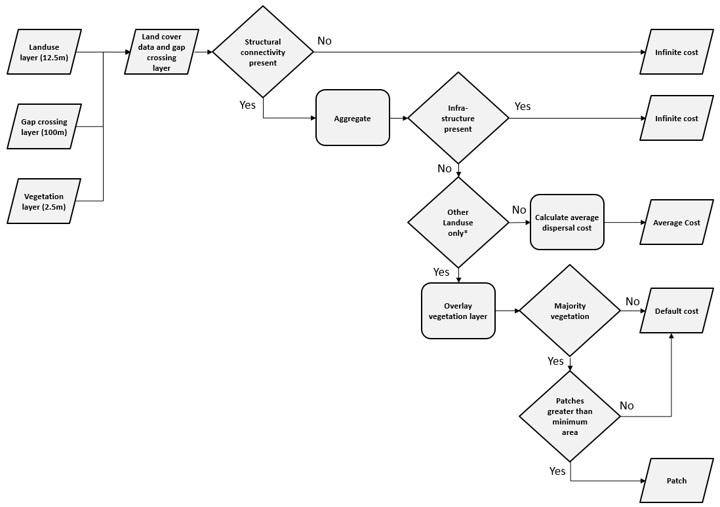

Processing flow chart describing the derivation of a raster layer for Case 4 (High resistance – where infrastructure has infinite cost) that represents patches of habitat and dispersal costs at a coarser pixel size than the original input data. *Other landuse refers to pixels which contain no roads/rails or hydrology e.g. mostly farmland.

|  |
| --- |
| **Tutorial - Create Patch and resistance layer**  Location of veg layer : “\TestData\Inputs_DefaultAndScenario\veg”  Location of gap-crossing layer : “\TestData\Inputs_DefaultAndScenario\gap_cross”  Location of landuse layer : “\TestData\Inputs_DefaultAndScenario\luse”  Location of landuse reclass text file : “\TestData\Inputs_DefaultAndScenario\luse_reclass.txt”    The final output from this step will be a map of habitat and a map describing resistance.  File:Exclamation mark red.pngNote Step 7: Once the run button has been clicked the GUI will become unresponsive until the script is done. Check the “Script Outputs” to see if it was successful. |

# Step 5: Running Model in Graphab

Now that the GAP

Note: For current version it is important that the raster input files are unsigned integer 16 bit (Formatting: unsigned integer 16). If Graphab crashes even if you are using unsigned integer 16 bit then the pixel size is too fine.

## Step 1: Start new project

File > New Project

## Step 2: Use Vegetation map to identify patches

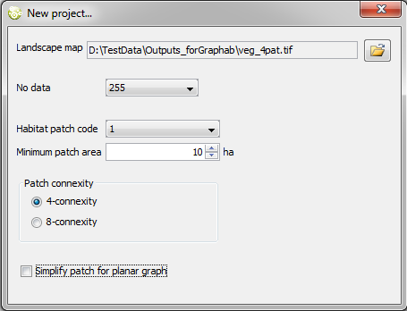

## Step 3: Use Landuse data

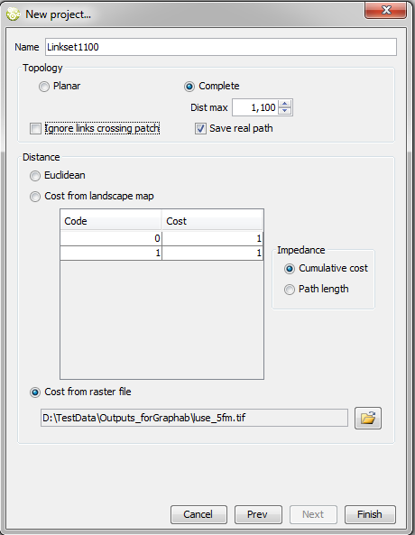

## Step 4: Obtain result

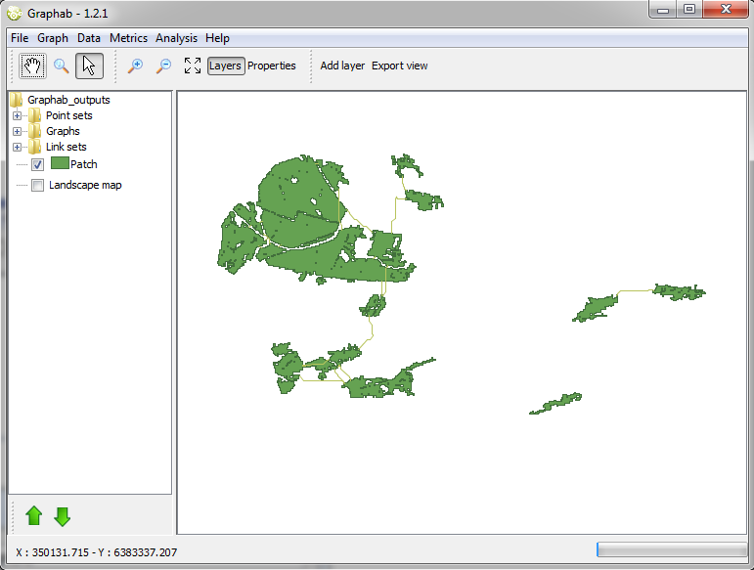

## Step 5: Create Graph

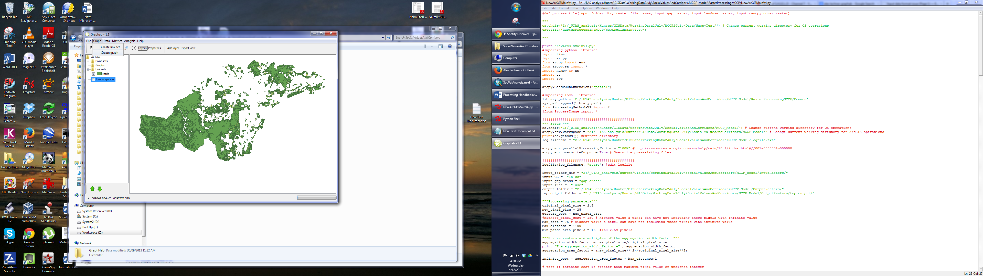

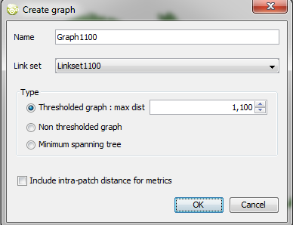

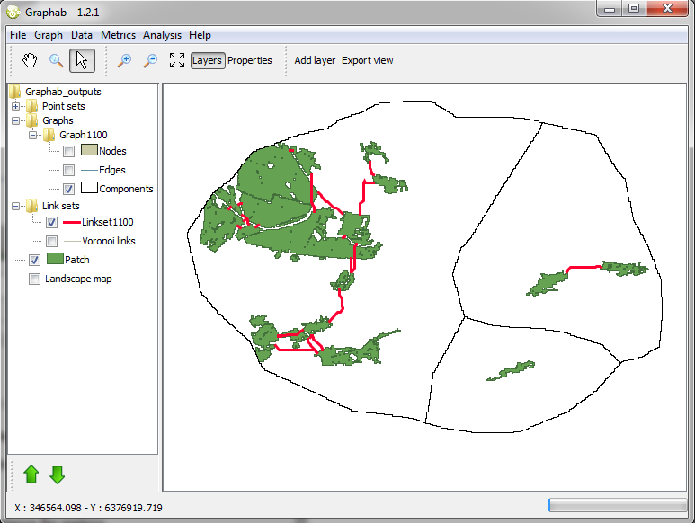

## Step 6: Analyse data

**Landscape-scale and patch-scale (Local and Delta) graph metrics**

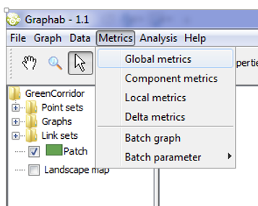

## Step 7: Export Data

Note you will need to export the nodes and components to open the output in ArcGIS all other GIS datasets can be found in the Graphab output folder.

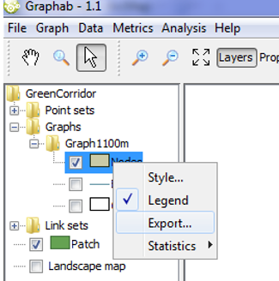

# Step 6: Running Circuitscape

The GAP CLoSR framework uses Circuitscape for local scale analysis (i.e. subset of entire region). This is because commonly the pixel size used in the regional analysis is too fine for Circuitscape to process. An alternative is to coarsen the pixel size and run Circuitscape for the whole region. However, this may mean the fine-scale dispersal behaviour characterised by the GAP CLoSR method may not be captured (see report for more details).

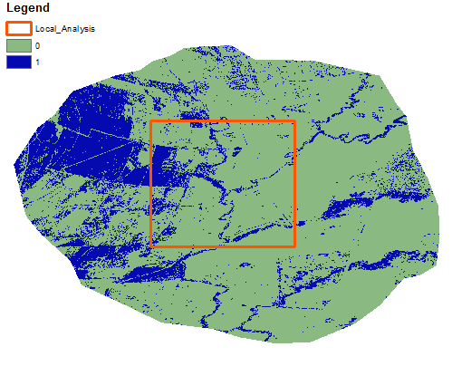

**Circuitscape is used to run local scale analysis for only a subset of a region using input data from Graphab and the original resistance layer.**

## Process data for Circuitscape

**Aim:** Clip layers, covert infinite cost areas to noData in the resistance surface and identify focal nodes.

**Input layers:** “patch.tif” (Patch map) output from Graphab and Resistance layer from the GAP CLoSR pre-processing (7.2).

**Output layer:** Focal Nodes layer (component or patch) and new Resistance layer. The Focal Nodes layer represents the focal areas or current sources, which Circuitscape treats as dispersal sources. These focal nodes are specified by a raster cell’s pixel value (ID). A single patch or source will be made up of multiple pixels with the same ID. The GAP CLoSR framework treats focal nodes as either patches or as components (patches that are interlinked but may be isolated from other groups of patches which form separate components). A key part of this processing step is allocating pixel values based on either patch or component IDs identified in Graphab. The choice of modelling connectivity between patches or components is explained within the GAP CLoSR report.

### Method:

1. Clip “patch.tif” (Patch map) output from Graphab and the original “Resistance layer” from the GAP CLoSR pre-processing (7.2).
2. Convert infinite cost value in the resistance layer to NoData. That way Circuitscape won’t calculate dispersal in these areas.
3. Assign values to pixels based on patches or components.

|  |
| --- |
| **Tutorial - Clip and modify resistance layer**  Location of Extent shapefile : “\TestData\Inputs_Circuitscape\Local_Analysis.shp”  Location of Resistance layer : “\TestData\Inputs_DefaultAndScenario\luse”    Note step 5: All values equal or greater than the infinite cost value will be converted to no data.  Note step 4 and 6: The outputs shall be saved as a ASCII file and also an ArcGIS grid. |

|  |
| --- |
| **Tutorial – Create clipped patch layer where focal nodes are patches**  Location of Extent shapefile : “\TestData\Inputs_Circuitscape\Local_Analysis.shp”  Location of Patches.tif : “\TestData\Inputs_DefaultAndScenario\luse” |

|  |
| --- |
| **Tutorial - Create clipped patch layer where focal nodes are components**  Location of Extent shapefile : “\TestData\Inputs_Circuitscape\Local_Analysis.shp”  Location of Patches.tif : “\TestData\ Graphab_outputs\patches.tif”  Location of Component shapefile : “\TestData\ Graphab_outputs\components.shp”    File:Exclamation mark red.pngNote, the “Component shapefile” needs to be exported from Graphab while “Patches.tif” is generated automatically. |

## Processing data in Circuitscape

**Aim:** Process Focal Nodes layer and new Resistance surface in Cricuitscape.

**Input layers:** Focal Nodes layer (component or patch) and new Resistance layer..

**Output layers:** Circuitscape current density maps.

**Method:**

Using the Focal Nodes layer (component or patch) and Resistance layer run Circuitscape. See Circuitscape manual for more details on the many options available

|  |
| --- |
| **Tutorial – Run Circuitscape with patches as focal nodes**  Location of Focal nodes layer : “\TestData\Inputs_Circuitscape\focalnodes.asc”  Location of resistance layer : “\TestData\ Inputs_Circuitscape\resistance.asc”    File:Exclamation mark red.pngNote, is recommended to Log-transform current maps. See Circuitscape documents for details. |

|  |
| --- |
| **Tutorial – Run Circuitscape with Components as focal nodes**  Location of Focal nodes layer : “\TestData\Inputs_Circuitscape\focalnodescomp.asc”  Location of resistance layer : “\TestData\ Inputs_Circuitscape\resistance.asc” |

# Troubleshooting

There are so many potential problems that you may encounter. Below are some possible common issues that may result in the Graphab process not working:

**Resolution don’t match**

1. Differences in projections
2. Incorrect raster format
3. Differing extents or pixels sizes

Sometimes it appears as though the resolutions do match even though they actually don’t.

Solution:

* Use “clip” to clip the raster
* Then use “raster mask” to remove areas and covert to nodata. Using only raster mask does not change the extents.

**Least-cost pathways outside of vegetation boundary**

Ensure that no data areas are specified when setting up new project

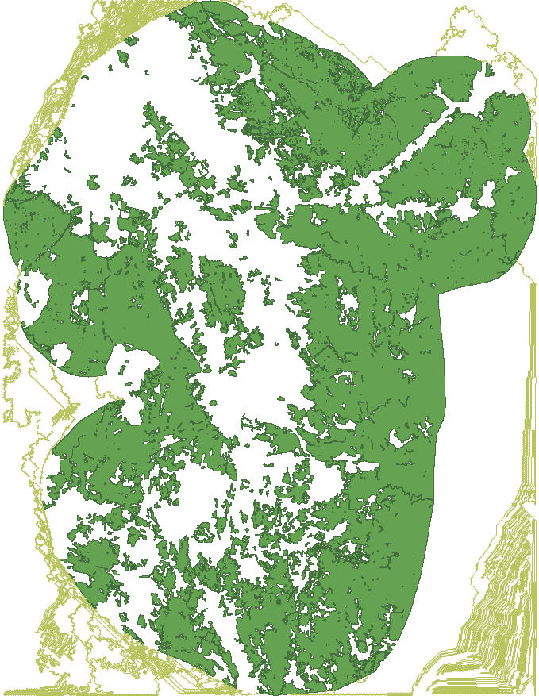 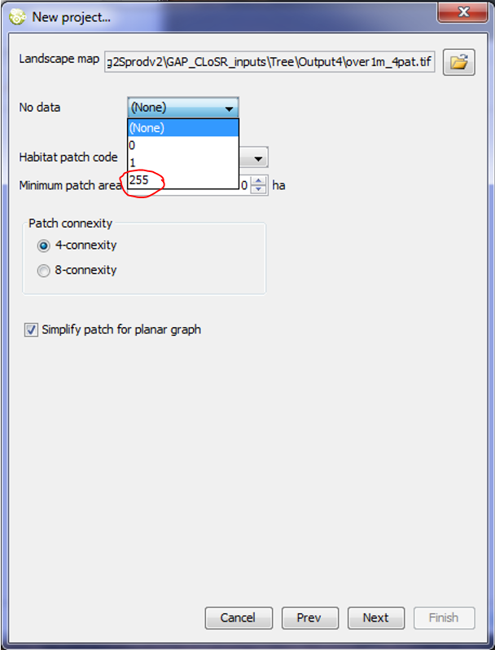

# Appendix – Installing and running GAP CLoSR Tools GUI

## Introduction

GAP_CLoSR_Tools is graphical user interface (GUI) software that has been developed to facilitate the use of the GAP CLoSR tools and methods previously developed by Alex Lechner as part of the Australian Government’s National Environmental Research Programme (NERP) Landscapes and Policy hub. GAP_CLoSR_Tools was developed by Michael Lacey, also as part of the NERP Landscapes and Policy hub. This GUI application is designed to integrate with tools used in the GAP CLoSR process. The purpose is to provide an easy to use means of generating input datasets for later processing using Graphab and Circuitscape which are other software used in the GAP CLoSR process.

Geoprocessing is accomplished using the geoprocessing tools of ESRI ArcGIS (version 10.0 or above). At the core of the GUI application is a set of Python script versions of the GAP CLoSR tools. The GUI has been designed so that users do not need to know about scripting or how to use Python. All of that is designed to run in the background. Once the application has been set up, the user just needs to enter the required variables and run the scripts using the GUI controls following the GAP CLoSR methods. Some additional GIS processing in ArcGIS may be required as outlined in GAP CLoSR documentation (eg. tutorial). Advanced users who are familiar with Python scripting and ESRI geoprocessing tools will have the option of modifying the scripts and a range of script-related settings.

## Installation

Installation files are available from <http://www.nerplandscapes.edu.au/GAP_CLoSR>. Currently the files are provided in a zip archive. To install the software just unzip the archive into your chosen directory. Preferably that directory should have no spaces in path. The installation file also contains example datasets and an associated scenario file.

## Required Files and Folders

The two main components of GAP_CLoSR_Tools are the GAP_CLoSR_Tools.exe file and a scripts folder. By default the scripts folder is called GAP_CLoSR_Code and must be that name if it is in the GAP_CLoSR_Tools folder.



The GAP_CLoSR_Code (scripts) folder contains Python scripts and a configuration file required to run those scripts.

There may also be a file named AltScriptPath.txt in the GAP_CLoSR_Tools folder. This file is not essential at the time of first use and will be created when the application is first run. This file is a text file which just contains the path to the scripts directory.

There may be a Scenarios folder in the GAP_CLoSR_Tools folder. This folder is created when the application is run if it does not already exist. The purpose of this folder is act as a default location to store scenario settings files. Scenario settings files can alternatively be stored elsewhere on the computer.

## Starting GAP CLoSR Tools

Start GAP CLoSR Tools by double-clicking the GAP_CLoSR_Tools.exe. The application will appear as a tabbed form.

## Configuring path to Python

Once downloaded open the Configuration Tab and ensure that the file path to Python (python.exe) is correct. A simple way of doing this is searching for “python.exe” in windows explorer. Then copy that file path + python.exe and paste it into the GUI. Once the python has been located click on save config.



## How to use the example datasets

From the 'File' menu select 'Load Scenario'. Browse to and select the scenario 'TestScenario.txt' text file in the 'Scenarios' folder. The scenario will load and most of the data-entry text boxes will be populated with text. At this stage the text in many of the text boxes will probably appear coloured red. Text will appear red if the dataset does not exist or the path is not correct. On the 'Default Rasters Generation' tab click on the browse button next to the 'Raster input and output folder (Root folder)'. Browse to and select the 'Inputs_DefaultAndScenario' folder. Most of the text in the text boxes on the 'Default Raster Generation', 'Scenario Options Processing' and 'Process Rasters for Graphab' tabs should then change to black.

Select the remaining datasets as follows:

On the 'Default Raster Generation' tab click on the browse button next to Input land-use shapefile and select 'luse.shp'.

On the 'Scenario Options Processing' tab click on the browse button next to Input change layershapfile and select 'ChangeLayer.shp'.

On the 'Process Rasters for Graphab' tab click on the browse button next to Reclass text file and select 'luse_reclass.txt'.

On the 'Process Rasters for Graphab' tab click on the browse button next to Output folder (Graphab) and select 'Outputs_forGraphab' folder.

Next go to the 'Create Circuitscape Inputs' tab and select the 'Output folder (Circuitscape)' by clicking on the associated browse button and selecting the 'Outputs_forCircuitscape' folder. Output raster names should turn black. Remaining datasets on the 'Create Circuitscape Inputs' tab can be browsed to in either the 'Inputs_Circuitscape' or 'Outputs_forCircuitscape' folders.

When text in all text boxes has turned black save the new settings by selecting 'Save Scenario' on the 'File' menu and creating a new settings file, preferably in the 'Scenarios' folder.

Things to remember:

* Files with .shp .txt or .asc extension need the full path specified
* Raster names must not have a path
* Output rasters are of ESRI GRID format unless otherwise specified
* Folders do not end in a slash character (\)
* If the text colour is red then the dataset or path does not exist
* If the text colour is black then the dataset already exists
* If the text colour is violet for a raster dataset then the name is not valid for ESRI GRID format.

When a tool is run any existing output datasets will be overwritten. To create new datasets use a different path or file names. For new output datasets the file name will appear red in the text box but will change to black after the tool has successfully run.

## Normal Use of the Toolset

In using GAP CLoSR Tools please refer to the GAP CLoSR documentation (http://www.nerplandscapes.edu.au/GAP_CLoSR) which can be accessed from the internet by clicking the green 'GAP CLoSR' on the front tab if you have internet access. There is also a tutorial document which will be accessible soon.

Normally a user of GAP CLoSR Tools will start at the 'Default Rasters Generation' tab and work through the tools by working down each tab and through the tabs going left to right. The 'Default Rasters Generation' tab is used to create default datasets. Additional scenario datasets can be generated using the tools on the 'Scenario Options Processing' tab. Inputs for Graphab are generated using tools on the 'Process Rasters for Graphab' tab using selected inputs generated on the first two tabs. Tools on the 'Create Circuitscape Inputs' tab are used to generate inputs from Circuitscape.

## Running Tools

There are two ways to run the tools, either individually or as a group. To run an individual tool, click the 'Run' button near the tool name. If any of the inputs are missing a dialogue box will appear listing the missing inputs and the run will be cancelled. Select any missing inputs using the text boxes or browse buttons and try again. While a tool is running the 'Run' button will be greyed out. There may be a pause while processing occurs. The 'Run' button will be enabled again when the tool has run. Afterwards, if you click on the 'Script Outputs' tab, a listing of tool run details will appear on the 'Script Text Output' window. Any errors will appear in the ‘Script Error Output' window.



## Running Multiple Tools

An alternative way to run the tools is to run them in groups. Tools on the 'Default Raster Generation' and 'Scenario Options Processing' tabs can be run together. Select tools to be run by clicking the 'Select' button next to the 'Run' button. When selected the 'Run' button will appear greyed out. On the 'Script Outputs' tab the 'Generate selected Default and Scenario input rasters' button will be enabled and will show the number of selected tools remaining to run. All selected tools can be run by clicking this button. They will run in the sequence in which they appear on the tabs and the number shown will count down showing the number of tools remaining to run. If an output dataset already exists a warning message will appear, asking if you would like to overwrite it. This warning message can be disabled using a check box on the 'Configuration' tab. After all scripts have run, output details can be reviewed on the 'Script Text Output' window and any errors will appear in the 'Script Error Output' window.

|  |
| --- |
| **Examples of configuration for runi** |

**Scenario**

There is only one tool on the 'Process rasters for Graphab' tab. It can be run from that tab or by selecting it and running it using the 'Process rasters for Graphab model' button on the 'Script Outputs' tab.

Tools on the 'Create Circuitscape Inputs' tab can also be run individually or together as a group in the same ways as previous tabs. When running them as a group, use the 'Create Circuitscape inputs' button on the 'Script Outputs' tab.

## Script Errors

Where there is an error in tool execution that has caused the tool to fail then an error message will appear in the 'Script Error Output' window. The causes of any errors are varied. Commonly encountered errors and solutions will be documented in the GAP CLoSR Tools Manual which is being prepared and should be available soon. Users who are familiar with geoprocessing using ArcGIS 10 and with Python scripting of geoprocessing may be able to trace the cause of any error. Otherwise users may wish to contact the developer of Gap CLoSR Tools.

## Computing Requirements

GAP CLoSR Tools has been tested on Windows 7 and 8. The application also needs .NET framework version 3.5 (or higher) installed on the computer and ArcGIS 10 (or higher). The tools can be adapted to run with ArcGIS 9.2 and 9.3.

Addition technical specifications will appear in the GAP CLoSR Tools Manual.

## Configuration Notes

Configuration settings are found on the last tab of the GAP CLoSR Tools application. This includes the ArcGIS Python application and details of the script folder and files. These files are loaded at application start-up and all text boxes on this tab should contain text which should be black. If any of the text boxes are blank or have red text then that indicates a problem with the settings file. The default scripts directory is the same folder as the GAP_CLoSR_Tools.exe file. The ArcGIS Python Application will depend on what version of ArcGIS 10 you have and can be (for example) 'C:\Python27\ArcGIS10.1\python.exe' or 'C:\Python27\ArcGIS10.2\python.exe' or alternatively just 'python' will work in most cases. If the text turns to black then it should be correct. Further configuration details will appear in will appear in the GAP CLoSR Tools Manual.